INDEX

PAGE

ACWW 18
Affiliations 13
Agenda (sample) 10
CHARACTER COUNTS! 15
Coins for Friendship/Dollars for Leadership 19
Creeds, National & Southwest 5
Dues 11
Educational Image 6
Essay & Artwork 12
Exclusive Rights, Logos/Trademarks 4
Family ChoicE-Media 16
Family Community Leadership (FCL) 14
Goals 9
Histories, National & Southwest 9
Logos & Trademarks 3-4
Mission of FCE 2
Past State Presidents (AZ & SW) 11
Programs/Lessons/Workshops 8
State Officers & Chairman 7-8
Stop Human Trafficking 17
Vision Statement of FCE 2

THE MISSION of the NATIONAL ASSOCIATION for
FAMILY and COMMUNITY EDUCATION

is strengthening individuals, families, and communities through:

CONTINUING EDUCATION

DEVELOPINT\G LEADERSHIP

COMMUNITY ACTION

VISION STATEMENT for NAFCE

Empowered members build better lives through friendship, practical knowledge, leadership, and advocacy. These qualities attract new members who join to become more caring, involved citizens.

INCORPORATION Incorporated May 5, 1975, in Raleigh, North Carolina, FCE functions as a not-for-profit 501(c)3 organization as defined under the Internal Revenue Code.

DO NOT COPY The following are registered or copyrighted trademarks of the National Association for Family & Community Education. A written license agreement MUST be obtained before using. Contact National FCE Headquarters for license agreement.

THE FCE Logo The FCE logo is the acronym for “Family and Community Education.” The logo should be used on stationery and envelopes. It shall be kept clean and free of clutter, so it can be easily recognize. The logo includes FCE as well as the workds. The logo should not be used within state outlines. The name of the state may be used in place of National. The logo is registered with the US Patent and Trademark Office and bears the registration number, 1,804,783. The color is PMS 308. It may also be printed in black.

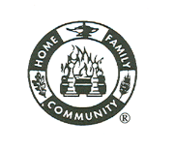THE Emblem Is composed of two concentric circles which typify the home, the family, the community, and the association. The hearth fire in the center symbolizes the home; the oak leaf sybolizes the strength of the home; the lamp of knowledge symbolizes the wisdom with which a home and family must be created; the wheat symbolizes productivity and richness of family and community life. Around these symbols are the words: Home Family and Community. The emblem is registered with the US Patent and Trademark office and bears the registration number, 1,892,407.

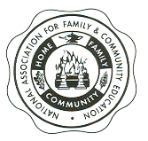THE Seal Is composed of three contentric circles. The two inner circles are the same as the emblem, with the third circle bearing the name of the organization. The seal is used for formal items, such as a certificate of honor or achievement. The seal is registered with the US Patent Office and bears the registration number, 1,891,429.
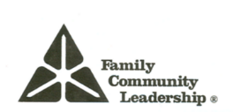THE FCL Logo is an acronum for Family Community Leadersship. The colors are green and blue. The triangle represents FCE, the Extension Service of the land grant colleges, and the community. To the side of the triangle appears the words of Family Community Leadership. It is registered with the US Patent Office and bears the registration number, 1,814,134.

THE FCE TODAY is an official trademark of the newsletter publication for the National FCE organization.

Family ChoicE-TV is the name used for the promotion of the Children & Television project. It can be used on T-shirts, banners, balloons, and flyers. It is registered with US Patent and Trademark Office.

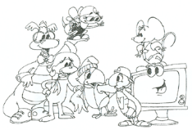FCE FRIENDS are characters to be used in FCE programs and promotion. The names of the characters are: Clarence the Caring Dragon, Micka the Good Citizen Monkey, Buzzee the Trustworthy Bee, Icky the Respectful Parrot, Webster the Responsible Turtle, Squeak the Fairness Mouse, and Tubee. They are registered with the US Patent and Trademark Office.

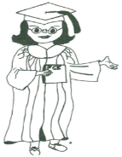Family ChoicE-Media and Professor Media are the names used for the promotion of programs and projects around all forms of media. The Professor is the mascot for this program. Both are registered with the US Patent and Trademark Office.
The Board of Directors may adopt such other symbols, emblems, seals, trademarks, copyrights, materials, and services as it deems necessary.

Exclusive Rights of Usage

The Corporation and its subordinate division, state, multi-state, territorial, county, local chapters, and members shall have the sole and exclusive right to use the name, FCE.

The Board of Directors shall prescribe the conditions governing the use of FCE’s name, symbols, emblems, seals, trademarks, copyrights, materials, and services by members, by state and county associations, and by local chapters.

The Corporation shall have the exclusive and sole right to the use, or to allow or refuse the use of such names, symbols, emblems, seals, trademarks, copyrights, materials, and services as it may legally adopt or has previously been used by the National Association for Family & Community Education.

NATIONAL FCE CREED

We will strive to promote a better way of life for all through fellowship, continuing education and service; to provide guidance in our homes and communities by the uniting of people to make the world a better place in which to live.

May we have pride in our role as homemakers and family and community educators and may our hearts be filled with joy as we serve.

Let us always be conscious of the needs of others and be strengthened by the Divine Light that guides us all.

Jean Beard Kestner
Tallahassee, FL
(Revised by her, 1995)

SOUTHWEST FCE CREED

To live as humbly as I can
To take what comes of good or evil, and grow, by my experiences, into a
better and more understanding person
To cling to the faith which I possess, and to live each day little better than
the day before
To see others through their eyes and not through my own
To be blind to the faults and see only the fine in every life
To so live that I have no need of secret places to hide that which I would
not have my friends know
To live the same when I am alone as I do before the world
To be exactly what my best friend thinks I am
To honor the teachings of my parents, and when I am called to leave this
sphere of action, may I live, in the memory of someone as a true friend.

Lila Newell, AZ, 1947

EDUCATIONAL IMAGE

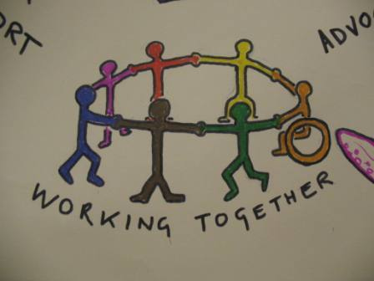

FCE is an organization of volunteers who work together to build strong families and communities. We produce educational materials that are used to strengthen knowledge and skills. We provide resources to develop leadership skills that enable people to make a difference. We work together to make our communities a better place in which to live.
2019 SWFCE OFFICERS

President Margaret Polen
6724 E, 35th Pl
Term ends: 2019 Yuma, AZ 5365-8204
928-726-7456
margaretmai531@gmail.com

President Elect Martha Crawford
1317 CR 288
Ballinger, TX 76821-7922
325-365-3890
mcrawford@wcc.net

Vice President

Secretary Marian Hannon
1693 W. Petunia Place
Term ends: 2019 Oro Valley, AZ 85737-7253
520-297-9712 or 520-444-1567
mbhannon@q.com

Treasurer Susie Martell
2175 E. Jonquil St
Term Ends: 2021 Oro Valley, AZ 85755
520-358-8621
martellsusan48@gmail.com

STATE CHAIRMEN

Editor Steve Polen
6724 E. 35th Pl.
Yuma, AZ 85365-8204
650-704-8961
spolenccnv@hotmail.com

International

Investments Bob Hannon
1693 W. Petunia Pl.
Oro Valley, AZ 5737-7253
520-444-1764
mbhannon@q.com

Membership

Historian Marian Hannon
(see previous page)

Budget Susie Martell
(see previous page)

HISTORY of NATIONAL FCE

FCE was organized in 1936 during the Triennial Conference of the Associated Country Women of the World (ACWW) held in Washington, D.C. at the Willard Hotel.

FCE incorporated May 5, 1975 in Raleigh, NC. The name was officially changed to the National Association for Family & Community Education at the Mid-Winter Board of Directors’ meeting Feb. 27, 1992 in Florence, KY.

FCE functions as a 501(c)3 non-profit association as defined under the Internal Revenue Service.

HISTORY of SOUTHWEST FCE

ARIZONA FCE became SWFCE Oct. , 2017, in Tucson, AZ. At the request of TXFCE a merger was arranged. NM, being between the two states, was asked to also join the merger. Bylaw proposed amendments were present to all who attended and the merger and name change passed.

GOALS & PURPOSES of SWFCE

TO:
- Increase appreciation of home life and good family relationships
- Put into practice improved methods of family life
- Make the community a better environment for family living
- Enhance the personal development of the individual FCE member and
increase his/her ability to assume leadership roles within the membership and community

PROGRAM and LESSONS and WORKSHOPS

All members should be directed toward enriching the quality of family living by applying research-based knowledge to home/family concerns and by counteracting misinformation. Leaders should assume the responsibility for attending leader training and for preparing and teaching a quality lesson/program/workshop.

ORDER for BUSINESS MEETINGS

Call to Order

Opening: Pledge of Allegiance, Creed, Vision & Mission Statements, and Welcome

Recognition of Visitors and New Members

Roll Call

Bonding

Appointment of Minutes Committee & Minutes

Special Appointments if necessary

Financial Report

Communications and Correspondence

Reports of Committees and Others

Special Orders

New Business

Announcements

Adjourn

- NOTE: a program/lesson/workshop is usually before or after the business meeting. It should NOT be part of the minutes. Minutes are for the Business Meeting ONLY. If a business meeting is to be interrupted for a program, then a recess is called, the program held, and the business meeting is resumed after.
DUES

All dues from local groups are sent to the County Treasurer along with the original, signed membership form. The County Treasurer sends state/multi-state and national dues to State/Multi-State Treasurer along with the original, signed membership form. This Treasurer sends National dues and the original, signed membership forms to the National Treasurer. Copies of forms may be made by the treasurers at all levels for their files.

Local and State Treasurers are to send only ONE check with the forms to make bookkeeping records easier. National FCE HQ will provide a complete list of membership forms provided to the State/Multi-State Treasurer.

PAST STATE PRESIDENTS (1962-2017: AZFCE and 2018- :SWFCE)

Dorothy Wood 1962-1965 Alberta Prall 1989-1990
Sylvia Nemec 1965-1967 Marian Hannon 1990-1992
Eliza Narramore 1967-1969 Eleanor Vancil 1992-1993
Orda Folmar 1969-1970 Margaret Mai (Polen) 1994-1995
Ruth Warner 1970-1971 Iris Gwinn 1996-1997
Mae Davis 1971-1973 Betty Galea 1998-1999
Doris Conahay 1973-1975 Linda Chambon-Gay 2000-2001
Dorothea Jackson 1975-1977 Nancy Armstrong 2002-2003
Pat Curtis 1977-1979 Raynetta McFadden 2004-2005
Jennie Villa Quiroz 1979-1982 Diana Givens 2006-2007
Betty Discher 1982-1983 Pat Warsek 2007-2008
Judy Mendehall 1983-1985 Margaret Mai (Polen) 2009-2012
Nancy Armstrong 1985-1987 Pat Warsek 2013-2015
Roseanne Paulson 1987-1988 Margaret Polen 2016-2019

FCE ESSAY and ARTWORK CONTEST

Objectives:
- To promote ethical values among children using the “Six Pillars of Character”
- To encourage students to improve their writing skills and drawing skills
- To create public awareness in the achievement of the students
- To create a national opportunity for local FCE members to participate in a nationwide project
- To promote and market FCE to the community during National FCE Week

Any current 4th grade student attending public, private, or home school is eligible to participate in the FCE Essay and Artwork Contest. The contest begins September 1 and runs through March 1 with a big promotion during National FCE Week.

First, Second, and Third Place National winners will be announced during the National FCE Conference. The families of the winners will be invited to attend the luncheon where the announcement will be made and prizes awarded.

Guidelines/rules and forms may be obtained online at: nafce.org

AFFILIATIONS

Local members, clubs, counties are members of SWFCE through payment of dues and sending them into the State Treasurer. (See bylaws)

All members in good standing (current with dues) are voting delegates. All those paying dues are also members of National FCE with all the privileges associated with that membership. The SWFCE President or Designated Alternate shall be the voting delegate at the National FCE Business Meeting or other Special Called Meeting.

SWFCE also pays dues to ACWW (Associated Country Women of the World) and has voting privileges at each Triennial Conference. The SWFCE President or Designated Alternate shall be the voting delegate at the ACWW Triennial Conferences. Both National FCE and ACWW MUST be informed of the Designated Alternate.

National Association For
Family & Community Education

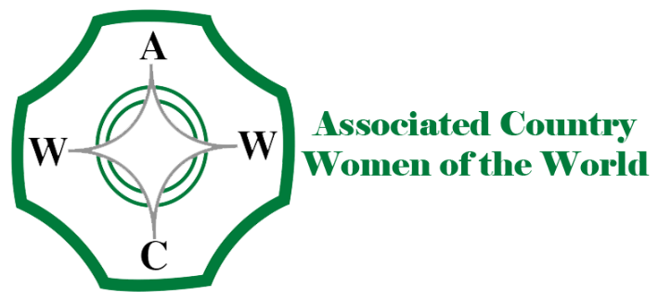

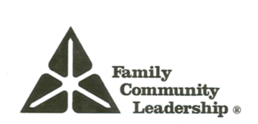

Family Community Leadership (FCL) is a leadership development, education and training program. Participants also learn the application of skills in leadership, public policy, and advocacy.

GOALS:

- Education
- Leadership
- Action

OBJECTIVES:
- Developing and strengthening leadership skills
- Applying skills to increase effectiveness of participation

Thirty hours of approved training in FCL topics will provide the graduate with a certificate of “Nationally Certified Leader.” Graduates are encouraged to continue in the application of the skills acquired and gain 60 hours by teaching others (using FCE provided materials/topics) – Education; working in the community—such as serving on a non-profit board – Leadership; and working on public policy issues -Action. Once 60 hours have been completed and documented, the graduate may apply for “Certified Trainer” status through National FCE.

For more information: Margaret Polen Martha Crawford
Marian Hannon Susie Martell

(address, info on page 7)

CHARACTERCOUNTS!

FCE is a partner with the Josephson Institute of Ethics and the CHARACTERCOUNTS! Program. National FCE is a member of the CHARACTERCOUNTS! Coalition. CHARACTERCOUNTS! is a registered trademark of the Josephson Institute of Ethics. Permission must be given by the Josephson Institute to use in any form.

OBECTIVES: To teach character development to children and adults using the
six core ethical values:

- Trustworthiness
- Respect
- Responsibility
- Fairness
- Caring
- Citizenship

EDUCATION: Use the storybooks developed by National FCE and corresponding
animal characters:
- Buzzee the Bee – Trustworthiness 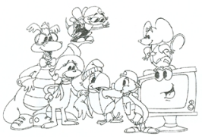
- Icky the Parrot – Respect
- Webster the Turtle - Responsibility
- Squeak the Mouse – Fairness
- Clarence the Dragon – Caring
- Micka the Monkey – Citizenship

ACTION: Work with schools, libraries, day care centers, churches, home schools,
Etc. Donate Storybooks, FCE friends, etc.

For materials or information contact:

National FCE Headquarters Josephson Institute of Ethics
73 Cavalier Blvd. Ste 106 8117 W Manchester Ste.830
Florence, KY 41042 Playa del Rey, CA 90293
859-525-6401 800-711-2670
nafcehq@fuse.net charactercounts.org
Family ChoicE-Media

Goal:

- To educate FCE members, parents, and the general public to the positive and negative influences of various media, video games, books, the internet, music, magazines, newspapers, radio, television, films and movies.

- Local clubs will reach the public in their communities with this information. Our goal is that FCE’s 8000 members will reach 4 people each, totaling 24,000 informed citizens.

Objectives:

- To educate members, parents, and general public
- How various media can be used to the maximum potential for education of children and youth
- How to make appropriate choices for uses of media for children and youth to enjoy
- Offer media education programs to help acquaint parents with how they become proactive to the exposure of children and youth to various media
- Help parents appreciate the benefits of the various media for their families
- Compile activities from the Family ChoicE-Media program for a report

PROFESSOR MEDIA™

STOP HUMAN TRAFFICKING

In 2014 National FCE took on the task of educating members, family, friends, and our communities about the growing epidemic of Human Trafficking. This is different from smuggling.

When someone is “smuggled” they willingly go along. They want to get to where they are going without getting caught. When someone is “trafficked” it is totally against their will.

Trafficked humans are used for sex, work, and other things. Many are drugged and all are afraid of what will happen to them. The United States is the NUMBER ONE USER of trafficked humans! Appalling!

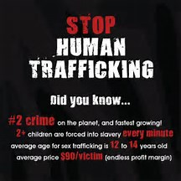

ASSOCIATED COUNTRY WOMEN of the WORLD
(ACWW)

ACWW is a non-political, non-sectarian international organization of 90 million members in women’s societies in over 70 countries. It works to improve the standards of living for all women and their families through its worldwide projects. ACWW also works with the United Nations on a consultative basis as a non-governmental organization (NGO).

The work of ACWW is supported through membership, Dollars for Friendship, donations, and contributions to specific projects. Monies collected by state affiliates are sent to the National FCE Treasurer using a designated form. At the end of the year the FCE state treasurer sends all monies collected in to the National organization.

All money donated is sent to ACWW.

The ACWW Triennial, a world conference, is held every three years. Any member may attend. State affiliates are given votes determined by the number of members. Individuals may support ACWW through individual dues, but do not vote. National organizations are given one vote each.

OBJECTIVES of ACWW:
- To work with people throughout the world
- To promote peace, friendship and international understanding
- To improve the standard of living for women and families

A04 Parkhall
40 Martell Road
London, SE 21 8EN
UK
acww.org.uk

COINS for FRIENDSHIP

This is a voluntary collection at all levels of the organization. The idea for this came from Mrs. Godfrey Drags, ACWW Member of Honor.

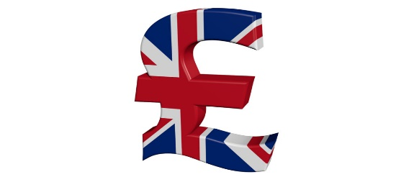
This Photo by Unknown Author is licensed under CC BY
This Photo by UnknowAuthor is licensed under CC BY-SA

DOLLARS for LEADERSHIP

In 1972, the “Key Leadership Conference” was held at the National 4-H Center. This “train-the-trainer” conference generated so much excitement for leadership that North Carolina delegates took up a collection of nickels.

A week later at the FCE Annual Conference, it was suggested that a fund be set up to accept donations from state associations. This fund would be titled “Nickels for National” and be designated only for leadership development. In 1987 the name was changed to “Nickels for Leadership.”

In 1996, funds from these donations were used to hold four regional trainings. Four scholarships per member state were given to grassroots members to attend the regional trainings.

Money from this fund has also been used to provide leadership speakers and defray costs of training at National.

The name was changed again to “Dollars for Leadership” to reflect the growing costs of training. Members continue to contribute to this fund voluntarily. All monies collected at the various levels are sent to the National Treasurer.

This Photo by Unknown Author is licensed under CC BY-SA

